**Simulation and Replication of Results: Binge Eating and EDE Global Scores**

Using the results from the paper “Comparison of Methods for Identifying and Assessing Obese Patients with Binge Eating Disorder in Primary Care Settings”, accessible at <https://www.ncbi.nlm.nih.gov/pmc/articles/PMC3197249>. Here, I simulate results from the limited information given and generate HLMs to replicate the results.

The data here is structured as follows:   
  
There are two response variables, Binge Frequency and EDE Global Scores. Binge Frequency was normalized by a log transformation, while EDE Global was already relatively normal. In simulating data from this, I used randomly selected values from a normal distribution with the means and variances given in the paper.   
  
There were a few different predictors, but only a few ended up being used in their model. Negative Urgency had a significant effect on binge frequency, but did not have a significant effect on EDE Global scores. The only variable which did influence the EDE Global scores was food-specific inhibitory control, but it did not significantly effect symptom change over time. The other variables -- inhibition, inhibition-switch, and inhibitory control in response to neutral stimuli – did not turn out to have a significant effect on the variables.   
  
In this study, there was a repeated measure – all variables were collected at the beginning, middle, end, and following up after the treatment. Time had a significant effect on both models, meaning that the treatment was successful. For Binge Frequency, there was a cubic relationship determined significant by the models, and for EDE Global Scores there was a quadratic relationship. Using R, I produced these curves to get an idea of what the models predicted about the outcomes. Time was used as a both a random and fixed effect, while the other variables were used as fixed effects.

X<-runif(100,min=-100,max=0)  
plot(X,0.002*X^3+0.08*X^2-.80*X,xlab="Time",ylab="BingeFrequency",type="p",main="Model Relationship",,xlim=c(-40,0),ylim=c(0,45))

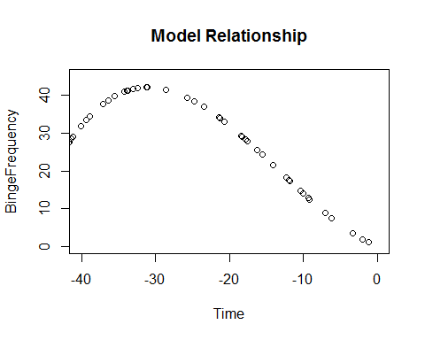

plot(X,0.01*X^2-0.16*X,xlab="Time",ylab="EDE.Global",main="Model Relationship between Time and EDE")

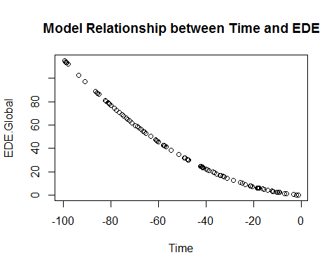

**b)** To simulate the data from the paper, I have created the response variables which follow the distributions outlined in the paper. The EDEGlobal was approximately normal at each time interval, so I used the provided means and standard deviations for each to recreate this variable. I used the same sample size as the paper.  
  
To simulate the Binge Frequency, I used a log-normal distribution, and calculated the coefficients. Since I knew the mean and standard deviation from the *untranformed* data, I calculated the parameters for the log-normal distribution from the provided parameters. That is, I used the following: $$μ_{parameter}={log⁡(\overline{X}}_{ }^{2}/\sqrt{\left(s^{2}+{\overline{X}}^{2}\right)} ) \\ {σ }_{parameter}=\sqrt{2(\log{X}-\log{μ_{parameter}})}$$

These provided parameters I could use in the log-normal distribution to determine appropriate untransformed Binge Frequency values. I then took the log of these to find the transformed values which were used in the models.

EDEGlobal.Base<-rnorm(17,2.67,0.81)  
BingeFreq.Base.reg<-rlnorm(17, meanlog = log(16.82^2/((8.62^2)+(16.82)^2)^.5), sdlog = (2*log(16.82)-2*log(16.82^2/((8.62^2)+(16.82)^2)^.5))^.5)  
BingeFreq.Base.tran<-log(BingeFreq.Base.reg)  
  
EDEGlobal.Mid<-rnorm(17,1.74,0.53)  
BingeFreq.Mid.reg<-rlnorm(17, meanlog = log(1.35^2/((2^2)+(1.35)^2)^.5), sdlog = (2*log(1.35)-2*log(1.35^2/((2^2)+(1.35)^2)^.5))^.5)  
BingeFreq.Mid.tran<-log(BingeFreq.Mid.reg)  
  
EDEGlobal.End<-rnorm(17,1.60,0.63)  
BingeFreq.End.reg<-rlnorm(17, meanlog = log(3.29^2/((7.9^2)+(3.29)^2)^.5), sdlog = (2*log(3.29)-2*log(3.29^2/((7.9^2)+(3.29)^2)^.5))^.5)  
BingeFreq.End.tran<-log(BingeFreq.End.reg)  
  
EDEGlobal.Follow<-rnorm(17,1.58,0.98)  
BingeFreq.Follow.reg<-rlnorm(17, meanlog = log(1.33^2/((2.47^2)+(1.33)^2)^.5), sdlog = (2*log(1.33)-2*log(1.33^2/((2.47^2)+(1.33)^2)^.5))^.5)  
BingeFreq.Follow.tran<-log(BingeFreq.Follow.reg)

As you can see below, the barplot of the Binge Frequencies at each point is very similar to that included in the paper itself. I also provide the transformed version of the same plot below it.

BingeFreq.reg<-cbind(BingeFreq.Base.reg,BingeFreq.Mid.reg,BingeFreq.End.reg,BingeFreq.Follow.reg)  
  
barplot(c(mean(BingeFreq.Base.reg),mean(BingeFreq.Mid.reg),mean(BingeFreq.End.reg),mean(BingeFreq.Follow.reg)),names.arg=c("Base","Mid","End","Follow-Up"),col=c("blue","red","green","yellow"))

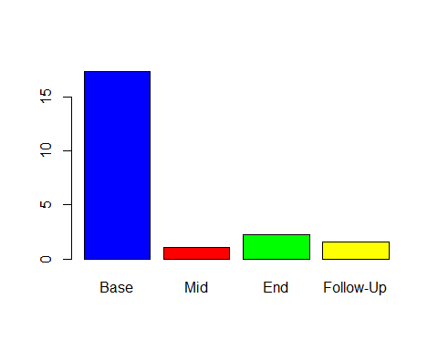

Next, I created the time variable. Since the study represents these in weeks, I simply created a variable which repeated each week 17 times. To perform similar tests as in the paper, I squared and cubed the time values, since these were considered important in predicting both response variables.   
  
I create a dataset which contains all this information. I then create a model to determine the effect of time on EDE scores. The Beta estimates from the paper (B1= -.16, B2=-.01) are quite close to these. Also importantly, they are highly significant, which means that the relationships detailed in the paper are applicable to my simulated data as well.   
  
I perform another regression on binge frequency and time, adding quadratic and cubed effects for time. This time, the model predicts quite differently than the paper, as the B3 coefficient is negative rather than positive. The other coefficients are the right sign and are relatively close to those outlined in the paper. All three of the variables came up significant.

time<-c(rep(0,17),rep(5,17),rep(10,17),rep(22,17))  
timesq<-time^2  
timec<-time^3  
  
data<-data.frame(cbind(EDEGlobal<-c(EDEGlobal.Base,EDEGlobal.Mid,EDEGlobal.End,EDEGlobal.Follow),BingeFrequency<-c(BingeFreq.Base.tran,BingeFreq.Mid.tran,BingeFreq.End.tran,BingeFreq.Follow.tran),time))  
  
  
summary(lm(data[,1]~timesq+data[,3]))

##   
## Call:  
## lm(formula = data[, 1] ~ timesq + data[, 3])  
##   
## Residuals:  
## Min 1Q Median 3Q Max   
## -2.01148 -0.43089 -0.01403 0.46027 1.74486   
##   
## Coefficients:  
## Estimate Std. Error t value Pr(>|t|)   
## (Intercept) 2.700179 0.184998 14.596 < 2e-16 ***  
## timesq 0.007270 0.001862 3.904 0.000228 ***  
## data[, 3] -0.211772 0.044479 -4.761 1.12e-05 ***  
## ---  
## Signif. codes: 0 '***' 0.001 '**' 0.01 '*' 0.05 '.' 0.1 ' ' 1  
##   
## Residual standard error: 0.7996 on 65 degrees of freedom  
## Multiple R-squared: 0.3103, Adjusted R-squared: 0.2891   
## F-statistic: 14.62 on 2 and 65 DF, p-value: 5.71e-06

summary(lm(data[,2]~time+timesq+timec))

##   
## Call:  
## lm(formula = data[, 2] ~ time + timesq + timec)  
##   
## Residuals:  
## Min 1Q Median 3Q Max   
## -2.03088 -0.56291 0.00739 0.45352 2.52807   
##   
## Coefficients:  
## Estimate Std. Error t value Pr(>|t|)   
## (Intercept) 2.7665547 0.2036449 13.585 < 2e-16 ***  
## time -1.1574511 0.1321391 -8.759 1.49e-12 ***  
## timesq 0.1260053 0.0191435 6.582 1.00e-08 ***  
## timec -0.0035910 0.0006174 -5.817 2.08e-07 ***  
## ---  
## Signif. codes: 0 '***' 0.001 '**' 0.01 '*' 0.05 '.' 0.1 ' ' 1  
##   
## Residual standard error: 0.8396 on 64 degrees of freedom  
## Multiple R-squared: 0.6924, Adjusted R-squared: 0.678   
## F-statistic: 48.03 on 3 and 64 DF, p-value: 2.225e-16

I create the negative urgency variable using the model that was used in the paper that came up significant, since there are no provided means and standard deviations in the paper. I then added some random error to prevent multicollinearity.   
  
This time, when negative urgency is added to the model, the time coefficients are more like that of the model and come up insignificant, but this is merely since the negative urgency variable was a linear combination of the Binge Frequency and time variables, respectively.

library(lme4)

## Warning: package 'lme4' was built under R version 3.3.2

## Loading required package: Matrix

negativeurgancy2<-ifelse(time!=0,(data[,2]+.8*time-0.08*timesq-0.002*timec)/(0.05*time-0.04),data[,2]/-.04)  
negativeurgancy3<-negativeurgancy2+rnorm(68,0,.9)  
  
summary(lm(data[,2]~time+timesq+timec+negativeurgancy3*time))

##   
## Call:  
## lm(formula = data[, 2] ~ time + timesq + timec + negativeurgancy3 *   
## time)  
##   
## Residuals:  
## Min 1Q Median 3Q Max   
## -1.30410 -0.22346 0.01472 0.16957 1.36079   
##   
## Coefficients:  
## Estimate Std. Error t value Pr(>|t|)   
## (Intercept) 0.4798149 0.7270926 0.660 0.51176   
## time -0.7668051 0.2838392 -2.702 0.00889 **   
## timesq 0.0783600 0.0305364 2.566 0.01271 *   
## timec 0.0008026 0.0009253 0.867 0.38906   
## negativeurgancy3 -0.0332881 0.0104617 -3.182 0.00229 **   
## time:negativeurgancy3 0.0353686 0.0028554 12.387 < 2e-16 ***  
## ---  
## Signif. codes: 0 '***' 0.001 '**' 0.01 '*' 0.05 '.' 0.1 ' ' 1  
##   
## Residual standard error: 0.4549 on 62 degrees of freedom  
## Multiple R-squared: 0.9125, Adjusted R-squared: 0.9055   
## F-statistic: 129.4 on 5 and 62 DF, p-value: < 2.2e-16

data<-data.frame(data,negativeurgancy3)  
  
  
ll1<-lmer(BingeFrequency~timec+timesq+time+(1|time))

## Warning: Some predictor variables are on very different scales: consider  
## rescaling

ll2<-lmer(BingeFrequency~timec+timesq+time+negativeurgancy3+(1|time))

## Warning: Some predictor variables are on very different scales: consider  
## rescaling

ll3<-lmer(EDEGlobal~timesq+time+negativeurgancy3+(1|time))  
ll4<-lmer(EDEGlobal~timesq+time+(1|time))  
ll5<-lmer(EDEGlobal~timec+timesq+time+(1|time))

## Warning: Some predictor variables are on very different scales: consider  
## rescaling

anova(ll1,ll2)

## refitting model(s) with ML (instead of REML)

## Data: NULL  
## Models:  
## ll1: BingeFrequency ~ timec + timesq + time + (1 | time)  
## ll2: BingeFrequency ~ timec + timesq + time + negativeurgancy3 + (1 |   
## ll2: time)  
## Df AIC BIC logLik deviance Chisq Chi Df Pr(>Chisq)   
## ll1 6 208.78 222.10 -98.390 196.78   
## ll2 7 205.67 221.21 -95.837 191.67 5.1054 1 0.02385 *  
## ---  
## Signif. codes: 0 '***' 0.001 '**' 0.01 '*' 0.05 '.' 0.1 ' ' 1

anova(ll3,ll4)

## refitting model(s) with ML (instead of REML)

## Data: NULL  
## Models:  
## ll4: EDEGlobal ~ timesq + time + (1 | time)  
## ll3: EDEGlobal ~ timesq + time + negativeurgancy3 + (1 | time)  
## Df AIC BIC logLik deviance Chisq Chi Df Pr(>Chisq)  
## ll4 5 177.94 189.04 -83.971 167.94   
## ll3 6 179.31 192.63 -83.656 167.31 0.629 1 0.4277

anova(ll4,ll5)

## refitting model(s) with ML (instead of REML)

## Data: NULL  
## Models:  
## ll4: EDEGlobal ~ timesq + time + (1 | time)  
## ll5: EDEGlobal ~ timec + timesq + time + (1 | time)  
## Df AIC BIC logLik deviance Chisq Chi Df Pr(>Chisq)  
## ll4 5 177.94 189.04 -83.971 167.94   
## ll5 6 178.56 191.88 -83.280 166.56 1.3822 1 0.2397

summary(ll2)

## Linear mixed model fit by REML ['lmerMod']  
## Formula: BingeFrequency ~ timec + timesq + time + negativeurgancy3 + (1 |   
## time)  
##   
## REML criterion at convergence: 229.6  
##   
## Scaled residuals:   
## Min 1Q Median 3Q Max   
## -1.85949 -0.70651 -0.02277 0.76132 2.15215   
##   
## Random effects:  
## Groups Name Variance Std.Dev.  
## time (Intercept) 0.5287 0.7271   
## Residual 1.0589 1.0290   
## Number of obs: 68, groups: time, 4  
##   
## Fixed effects:  
## Estimate Std. Error t value  
## (Intercept) 5.537061 1.494998 3.704  
## timec -0.006954 0.002731 -2.546  
## timesq 0.248183 0.090046 2.756  
## time -2.281721 0.717985 -3.178  
## negativeurgancy3 0.042028 0.018963 2.216  
##   
## Correlation of Fixed Effects:  
## (Intr) timec timesq time   
## timec -0.579   
## timesq 0.659 -0.992   
## time -0.807 0.930 -0.967   
## negtvrgncy3 0.858 -0.521 0.597 -0.719  
## fit warnings:  
## Some predictor variables are on very different scales: consider rescaling

summary(ll4)

## Linear mixed model fit by REML ['lmerMod']  
## Formula: EDEGlobal ~ timesq + time + (1 | time)  
##   
## REML criterion at convergence: 188.2  
##   
## Scaled residuals:   
## Min 1Q Median 3Q Max   
## -2.3647 -0.4662 -0.1063 0.6120 2.2437   
##   
## Random effects:  
## Groups Name Variance Std.Dev.  
## time (Intercept) 0.01332 0.1154   
## Residual 0.72047 0.8488   
## Number of obs: 68, groups: time, 4  
##   
## Fixed effects:  
## Estimate Std. Error t value  
## (Intercept) 2.821634 0.225142 12.533  
## timesq 0.008387 0.002266 3.701  
## time -0.233052 0.054131 -4.305  
##   
## Correlation of Fixed Effects:  
## (Intr) timesq  
## timesq 0.611   
## time -0.747 -0.964

Finally, I use the lme4 package to compare the models outlined in the paper – using time as a random intercept, and seeing which is more significant. In this sense, the models appear to line up with those of the paper, as the most significant model are those which are used in the paper, ll1 and ll4. That is EDEGlobal ~ timesq + time + (1 | time) and BingeFrequency~timec+timesq+time+negativeurgancy3+(1|time) proved to be the best models of the ones I tested, which aligns with what the paper concluded.